# **Online Shopping App**

## 230701229

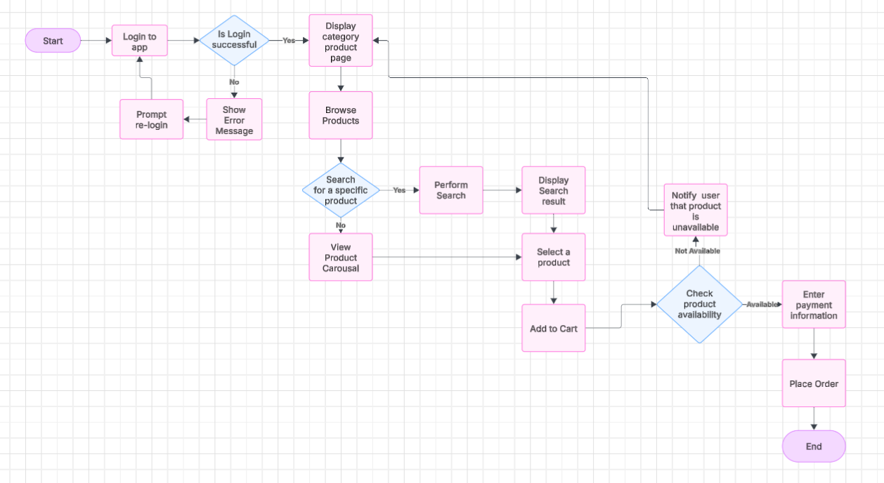

**Task Analysis:**

Task analysis is the process of breaking down user activities into smaller tasks to understand their goals, behaviours, and challenges when interacting with a product. It helps in designing an intuitive and efficient user interface.

**Steps in Task Analysis:**

1. Identify the List the tasks users need to perform to achieve their goals.
2. Break Down Tasks into Steps – Analyze each task step-by-step.
3. Identify Challenges and Pain Points – Look for friction points that might hinder task completion.
4. Optimize the Flow – Redesign tasks for better usability and efficiency

**Steps in Online Shopping app:**

* 1. Open the app.
  2. Search for a product.
  3. Browse categories and select items.
  4. Add items to cart.
  5. Review the product.
  6. Choose a payment method and complete payment.
  7. Track order until delivery.

**User Flow:**

User flow is a visual representation of the path a user takes within an app or website to complete a specific task. It helps designers create seamless navigation and an efficient interface.

**KEY ELEMENTS OF USER FLOW:**

· **Entry Point:** Where the user starts (e.g., home page, login screen).

· **Decision Points:** Choices the user makes (e.g., selecting a product category).

· **Actions:** Steps the user takes (e.g., adding items to the cart).

· **Exit Point:** The final destination (e.g., checkout confirmation).